# **Invoice Application**

Table of Contents

Invoice Application 1

Introduction 2

Detailed user requirements 2

Knowledge Evidence 2

What is metric? 2

What is domain modelling? 2

Detailed UI elements 2

How to login to the application: 2

# **Introduction**

The requirements were to create an application to record customers and invoices.

# **Detailed user requirements**

The requirements were to be able to search invoices by a number and search for customers by their name, provide the ability to edit invoice and customer details, create a login screen to the application and allow the user to select a background image.

# **Knowledge Evidence**

## **What is metric?**

Metrics are parameters or measures of quantitative assessment used for measurement, comparison or to track performance or production. A software metric is a standard of measure of a degree to which a software system or process possesses some property. For example, the number of errors per person hours would be metric.

## **What is domain modelling?**

Domain modelling is a way to describe and model real world entities and the relationships between them.

# **Detailed UI elements**

## **How to login to the application:**

To log in to the application you input the correct username and password and hit login. The characters in the password textbox are shown as asterisks.

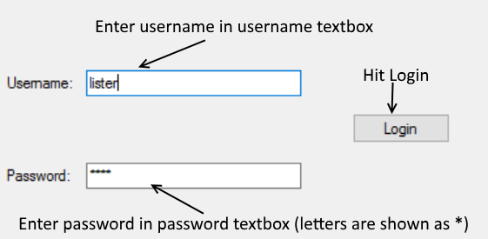

If you input the wrong username or password a message is shown saying to the user Input Error and to try again as shown below.

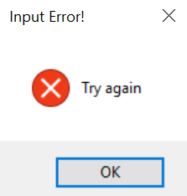

**How to search for customers by name:**

Input the customer name into the text box and hit search. 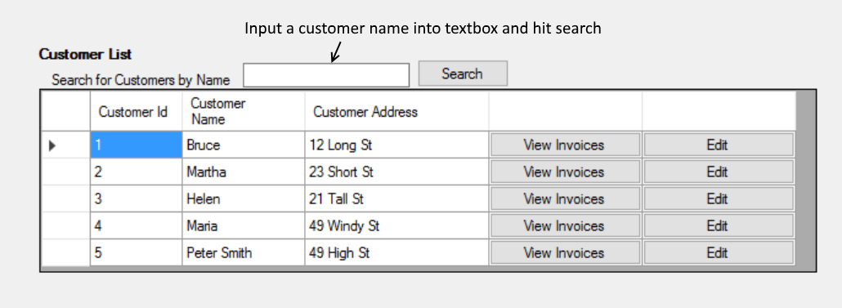

The customer list will then be filtered to show only customers of the given name.

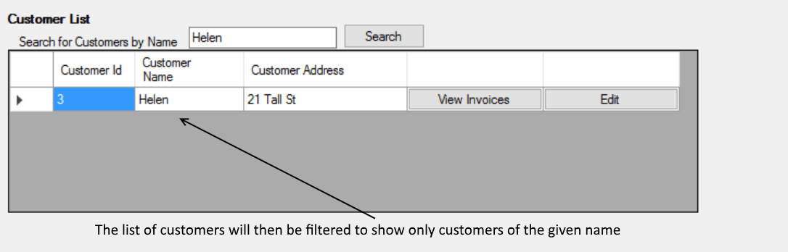

**How to search for a invoice by id:**

Input the invoice id into the text box and hit search.

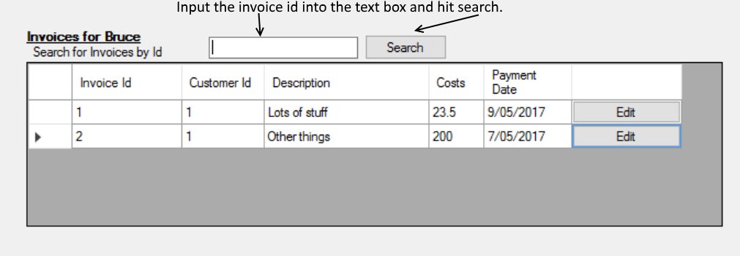

The invoice list will then be filtered to show only the invoice of the given id.

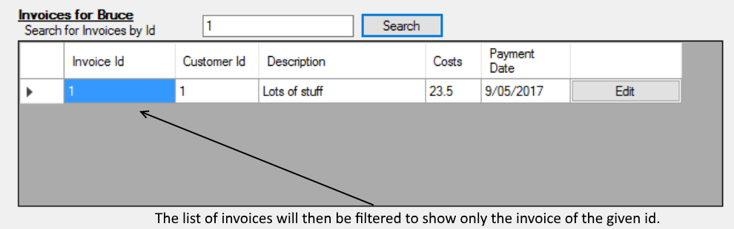

**How to add a customer:**

Input a customer name and address into the fields and hit add. The customer id field is auto-populated with the next customer id. The new customer will then be shown in the customer list.



If you hit add before filling in all the fields the user will be displayed a message saying to try again.

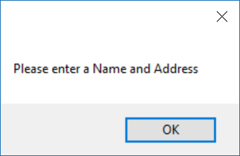

**How to view invoices for a customer:**

Search for a customer by their name and hit view invoices.

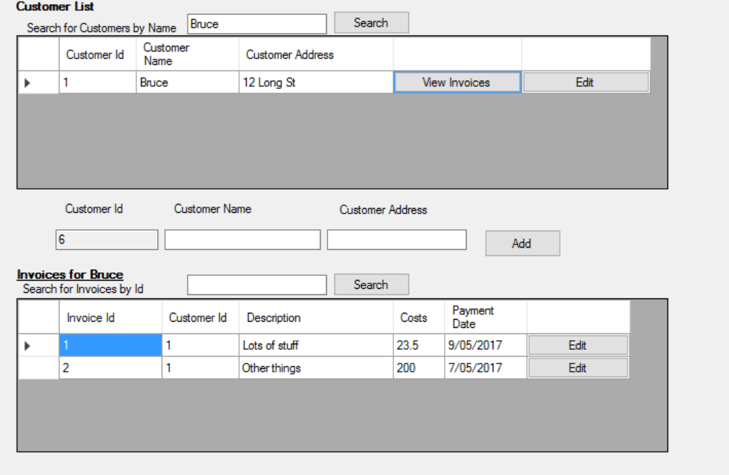

Any invoices associated with the customer will be displayed in the invoice list below.



**How to add an invoice:**

Input a description, cost and payment date and hit add. The invoice id field is auto-populated with the next invoice id. The new invoice will be shown in the invoice list.

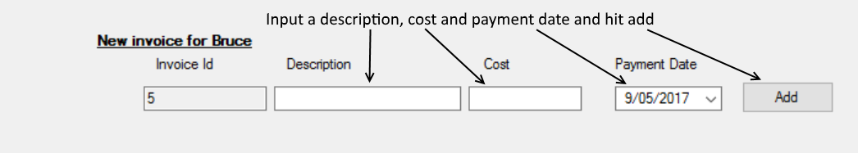

If you hit add before filling in all the fields the user will be displayed a message saying to try again.

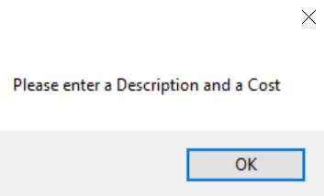

**How to edit a customer:**

Click edit on the customer you want to edit. The details of the customer will be populated in the fields.

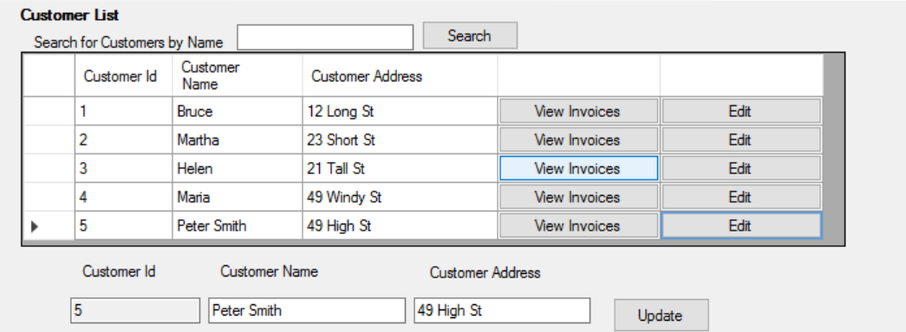

Change the details you want and hit update and the newly updated customer will show in the customer list.

**How to edit a invoice:**

Click edit on the invoice you want to edit. The details of the invoice will be populated in the fields.

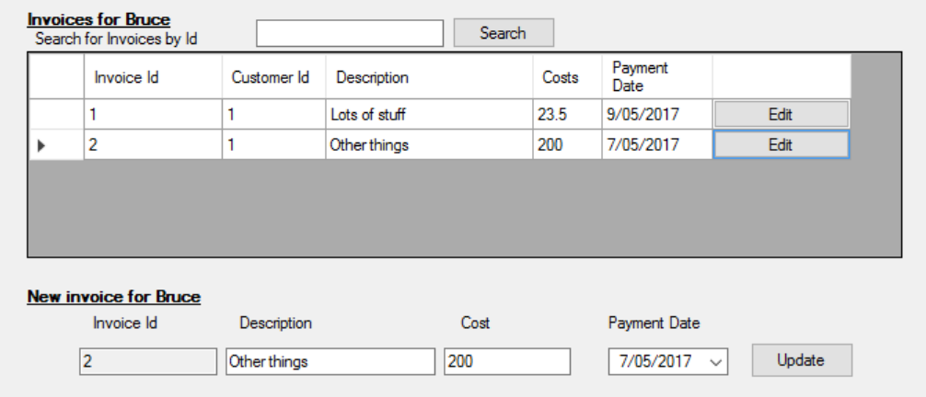

Change the details you want and hit update and the newly updated invoice will show in the invoice list.

**How to change the background image:**

1. In the top left of the screen you will see a toolbar saying background, click that. You will be displayed with three options:

* Image 1,
* Image 2,
* None.

1. If you already had the background changed and wanted to change back to normal hit none, otherwise you have two backgrounds to choose between.

# **References**

1. <https://en.wikipedia.org/wiki/Software_metric>
2. [https://en.wikiversity.org/wiki/Software_metrics_and_measurement](https://l.messenger.com/l.php?u=https%3A%2F%2Fen.wikiversity.org%2Fwiki%2FSoftware_metrics_and_measurement&h=ATN5rWAYgEDPoyrqoufqjad4iyv9nEmLretNe7_2YQ2qbsOMubfbJKTbvcVId46uRJ8yY51C2pQxzFNOYCo2dhql0xjHnc7T2OxjDW1MU3Pc4tXE8Jqj63nIQkaZKZGGrOsftqSD)
3. [http://www.scaledagileframework.com/domain-modeling](https://l.messenger.com/l.php?u=http%3A%2F%2Fwww.scaledagileframework.com%2Fdomain-modeling%2F&h=ATN5rWAYgEDPoyrqoufqjad4iyv9nEmLretNe7_2YQ2qbsOMubfbJKTbvcVId46uRJ8yY51C2pQxzFNOYCo2dhql0xjHnc7T2OxjDW1MU3Pc4tXE8Jqj63nIQkaZKZGGrOsftqSD)